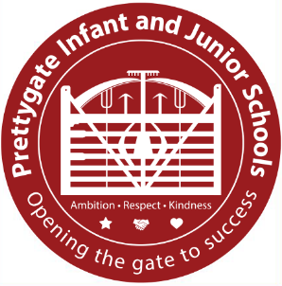
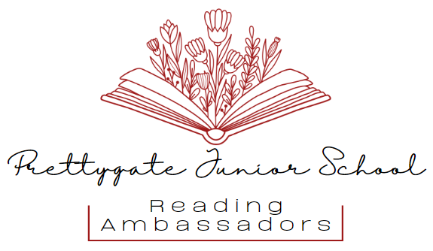

Prettygate Junior School
Reading Ambassador Application Form
Prettygate Junior School is looking to recruit pupils to become Reading Ambassadors to help promote reading and reading for pleasure across our school. Our meetings will take place on Wednesday lunchtimes from 12:45-13:15 in the library.
As a Reading Ambassador, you will help make our school a place where everyone can discover, enjoy and share great books. You will be a reading role model, recommending books and authors, sharing reviews and encouraging others to read. You will help keep the library and reading spaces tidy, organised and welcoming, as well as helping to make sure our school and classroom libraries are up to date with exciting new books and authors. You will work with other Reading Ambassadors to organise book-themed activities, competitions, challenges, quizzes and special reading events. Most importantly, you will listen to other pupils’ ideas and bring your own creative ideas for making reading fun and exciting across Prettygate Schools.

A great Reading Ambassador has a passion for reading and enjoys sharing their love of books with others. They are enthusiastic, responsible and organised, helping to care for books and keep reading spaces tidy and welcoming. They are creative and full of ideas, work well as part of a team and are a positive role model who encourages others to enjoy reading.
If you think you would be perfect for the role, please fill in the application overleaf, and return to Mrs Parkins (3PJ) by Friday 24th October.
I look forward to receiving your application!
Mrs Parkins
Prettygate Needs YOU!
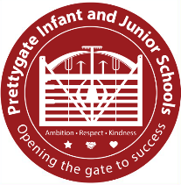
Name:
Class:
Why do you want to become a Reading Ambassador?
In school, what do you enjoy about reading?
How do you think you could encourage people at school to read more?
What book are you currently reading?
What is your favourite book that you have either read or had read to you and why?


